Categorical and Regression Tree model of trees in California
By: Preston Heen
3/9/2020
Introduction
In this lab I wanted to model the dominant trees in California using a categorical and regression tree (CART) model. The CART model is easy to interpret the classification tree and understand. We are applying the models to all fields to find new patterns (Nijhawan 2018). The goal of this lab is to use a CART model to predict the dominant tree species in California.
Methods
This data was collected all over California, and it contained species like Douglas fir, blue oak, and western juniper. This data was downloaded from the Forest Inventory Analysis plots in California. The purpose of this lab was to be able to predict the areas where dominant tree species are present in California. The predictor variables I used were annual precipitation, annual temperature, max temperature of warmest month, and minimum temperature of coldest month.
Model Run | Independent Variables | Complexity Parameter
1 | Annual Precipitation,  Annual Temperature,  Max Temperature | 0.02
2 | Annual Precipitation,  Annual Temperature,  Max Temperature | 0.002
3 | Annual Precipitation,  Annual Temperature,  Max Temperature | 0.0002
4 | Annual Precipitation,  Annual Temperature,  Max Temperature, Min Temperature | 0.0002
5 | Annual Precipitation,  Annual Temperature,  Max Temperature, Min Temperature | 0.002
6 | Annual Precipitation,  Annual Temperature,  Max Temperature, Min Temperature | 0.02
7 | Annual Precipitation,  Max Temperature, Min Temperature | 0.0002
8 | Annual Precipitation,  Max Temperature, Min Temperature | 0.002
9 | Annual Precipitation,  Max Temperature, Min Temperature | 0.02

Results
The results of this lab was a predictive map of dominant species. There were predictions of 14 different species. The model I chose to make a map of was model , because it had the low relative error (0.68577) and high accuracy (0.3908). The p-value of each prediction was $2.2*{10}^{-16}$.

Table 2. The Pruning Tree and variable importance
Model Run | Terminal Nodes | Relative Error | Cross-validation Error | x-validation standard deviation | Annual Temp | Annual  Precipitation | Max  Temp | Min  Temp
1 | 4 | 0.81986 | 0.82220 | 0.0056936 | 52 | 22 | 27
2 | 21 | 0.70551 | 0.71853 | 0.0061648 | 37 | 25 | 38
3 | 763 | 0.42462 | 0.69352 | 0.0062398 | 32 | 35 | 34
4 | 806 | 0.38792 | 0.67422 | 0.0062882 | 25 | 27 | 25 | 23
5 | 25 | 0.68577 | 0.70639 | 0.0062030 | 29 | 21 | 26 | 25
6 | 4 | 0.82190 | 0.82512 | 0.0056762 | 29 | 21 | 26 | 25
7 | 740 | 0.41480 | 0.67744 | 0.0062807 |  | 36 | 33 | 31
8 | 28 | 0.68095 | 0.70975 | 0.0061927 |  | 31 | 36 | 33
9 | 4 | 0.82000 | 0.82088 | 0.0057014 |  | 46 | 18 | 36

Table 3. Confusion Matrix
Model Run | Accuracy | 95 % Confidence Intervals | Kappa Statistic | P-value
3 | 0.6228 | (0.6119, 0.6337) | 0.5963 | $$2.2*{10}^{-16}$$
5 | 0.3908 | (0.3799, 0.4018) | 0.3401 | $$2.2*{10}^{-16}$$
7 | 0.6324 | (0.6215, 0.6432) | 0.6063 | $$2.2*{10}^{-16}$$

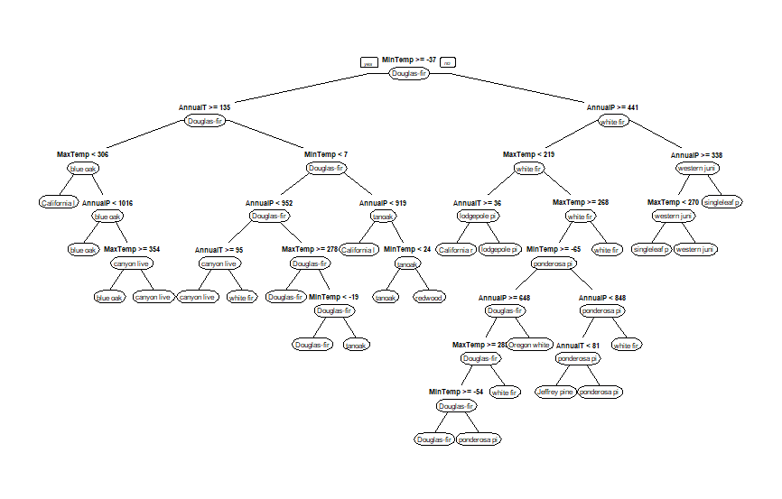
Figure 1. Categorical and Regression Tree, predicted trees from predictor variables.
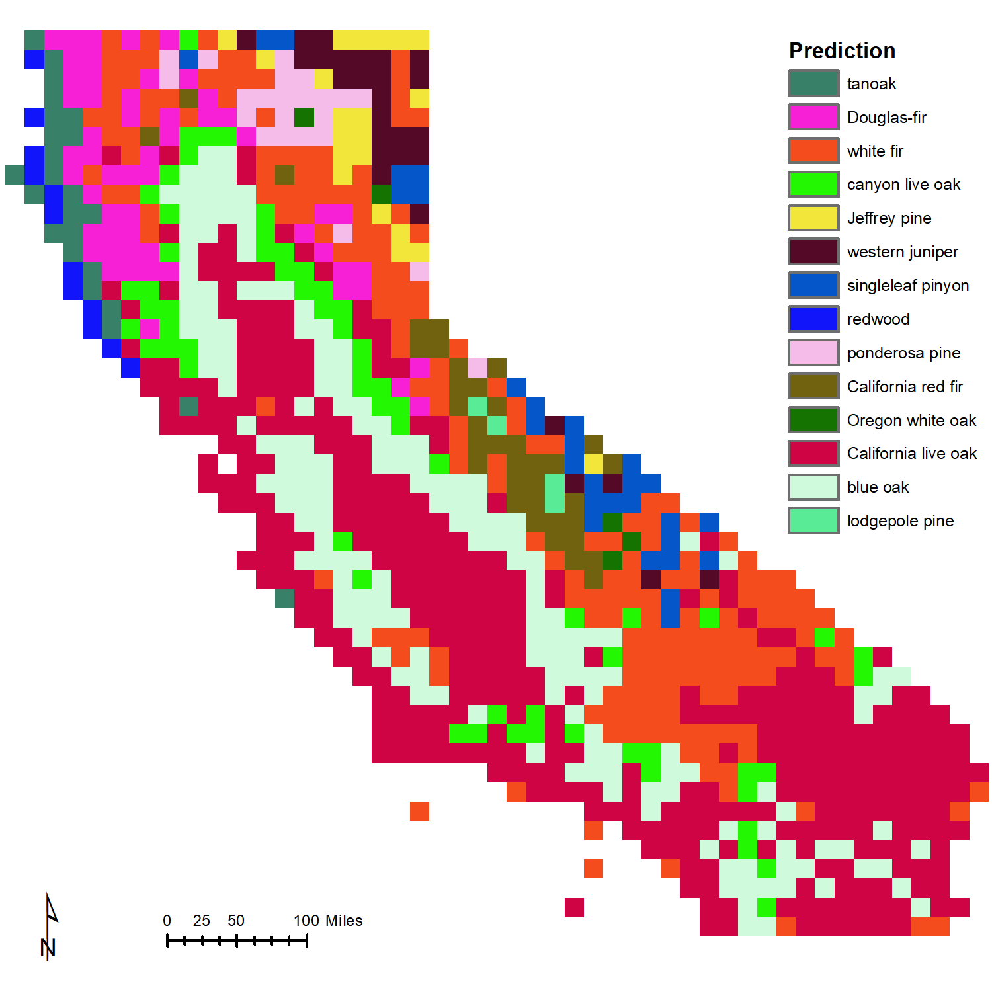
Figure 2. Map of California showing CART prediction where each dominant species could be found.
Discussion
In this lab I learned how to run a categorical and regression tree model, and made a predictive map of dominant tree species. My model predicted 14 different dominant species, and I am not sure if the California live oak is distributed as far south and inland. I think this model could be overfit, but then the accuracy also decreases as I make the model more complex.
Acknowledgements
I want to thank the Forest Inventory Analysis program for their provision of free data.

References
Nijhawan, V. K., Madan, M., & Dave, M. (2018, August 31). An Analytical Implementation of CART Using RStudio for Churn Prediction. Retrieved from https://link.springer.com/chapter/10.1007/978-981-13-0586-3_11

